* Steps to Install Python3 for Windows:
* Download python3 from:
* <https://www.python.org/downloads/>
* run
* 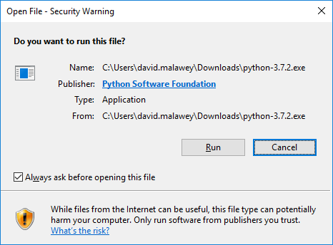
* 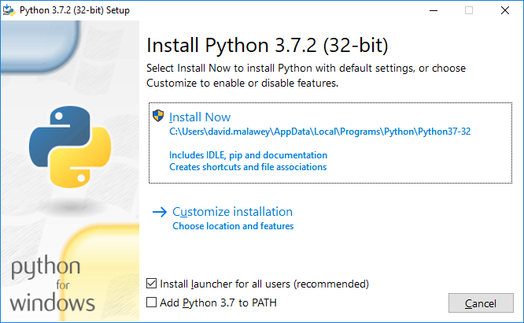
* Go back to the installer to add features
* 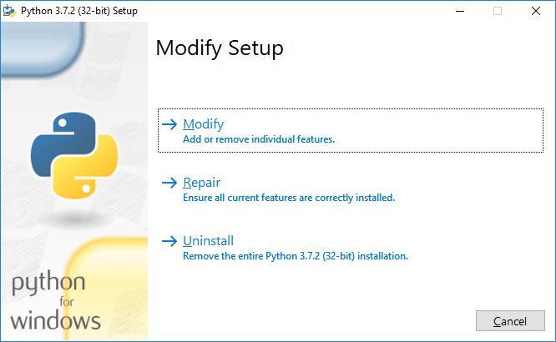
* Choose modify
* Add these check boxes
* 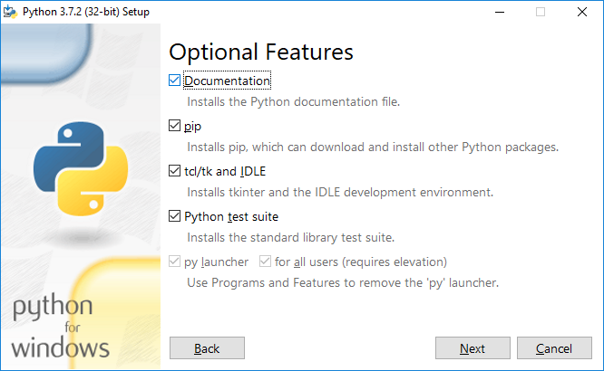
* Make these instructions
* 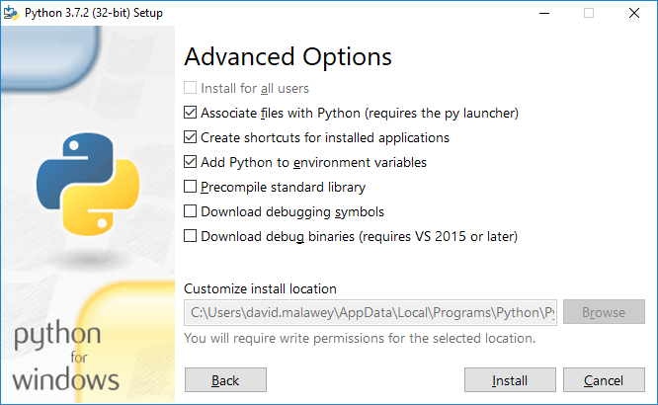
* Click Install.
* Open up the command prompt: press windows key, type “cmd”, then enter.
* 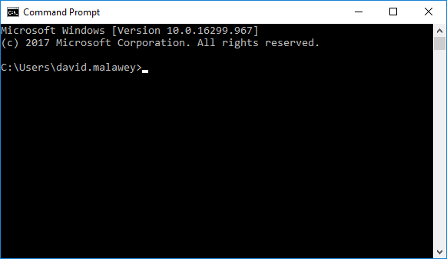
* Type pip3, enter and verify that the command prompt returns a list of commands available.
* Next, type the following command
* Pip3 install pygame
* Look for the following output
* 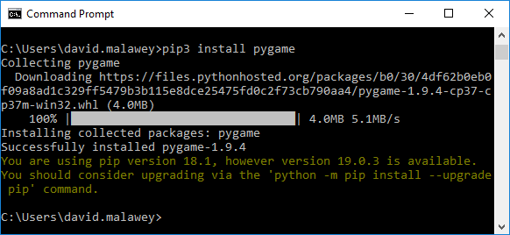
* Type into command prompt and enter:
  + “python”
  + Make sure that python 3.x will run
* Download the Scuttle controller
* Navigate using “cd” command to the folder where the controller files are stored
* Run this command:
  + Python udp_client.py
  + This window should pop up
  + 